**EXPERIMENT 6: HANGAROO GAME**

**(PROOF TESTING)**

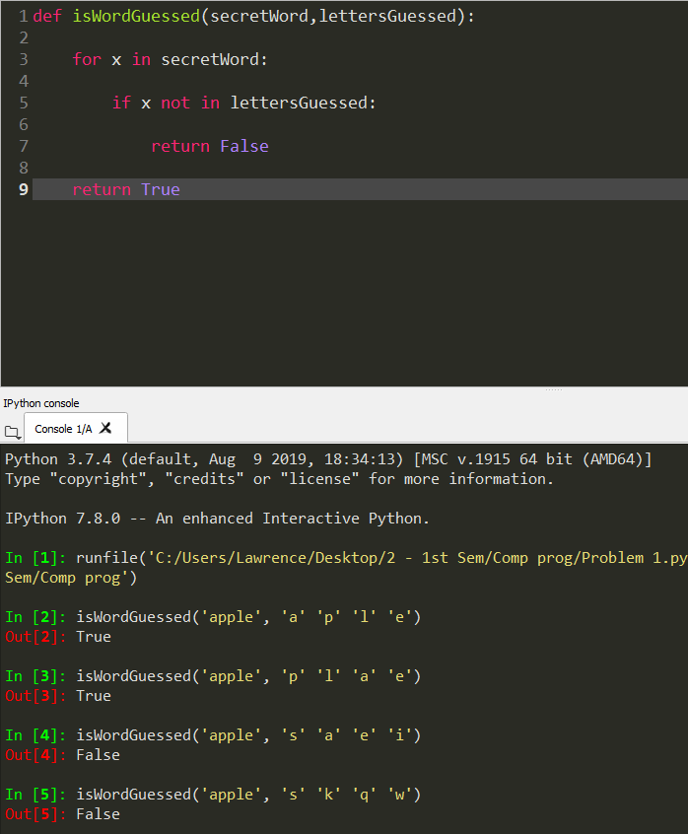Problem 1

🡨 All wrong guesses

🡨 All correct guesses

🡨 Two wrong guesses

🡨 All correct guesses

(random order)

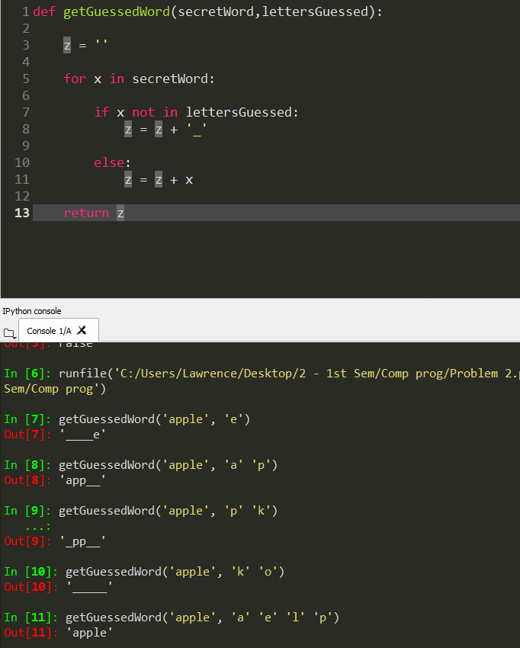Problem 2

🡨 All letters are

guessed

🡨 All wrong guesses

🡨 One correct guess

🡨 All correct guesses

🡨 One correct guess

Problem 3

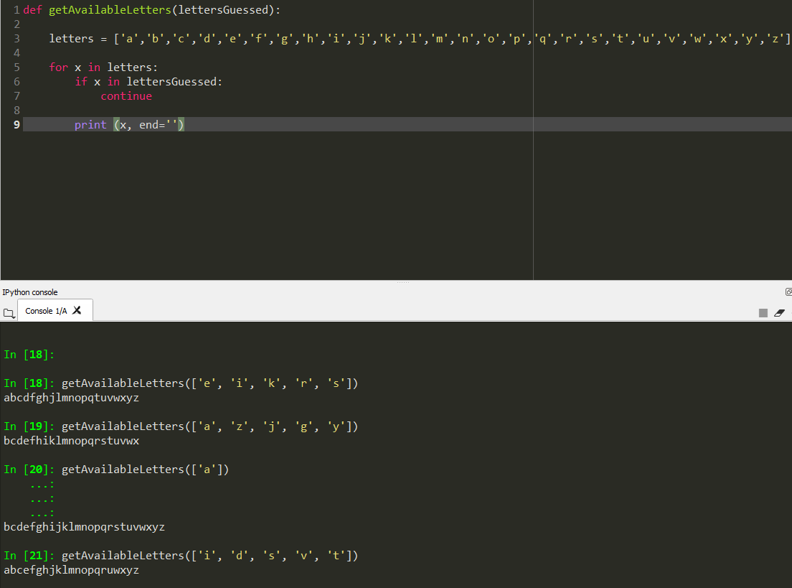

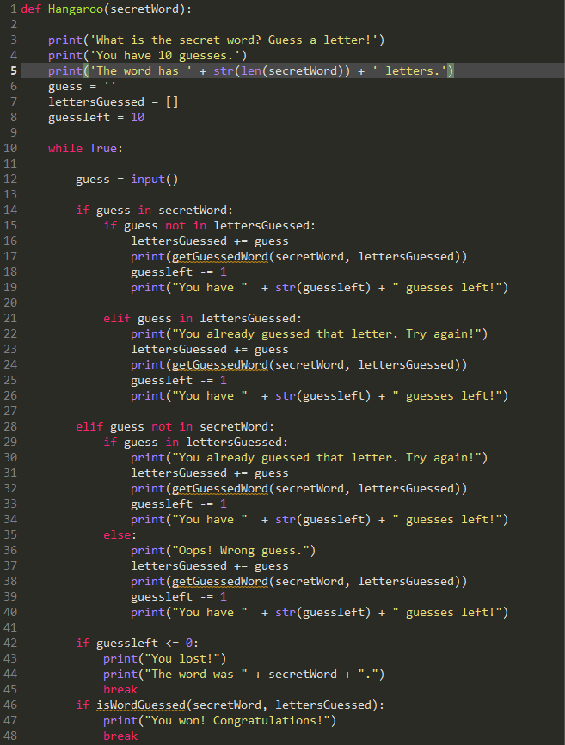Problem 4

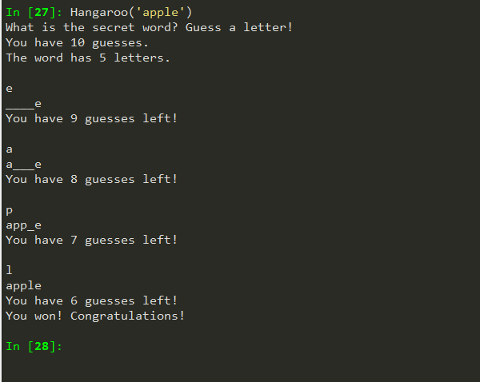The user won

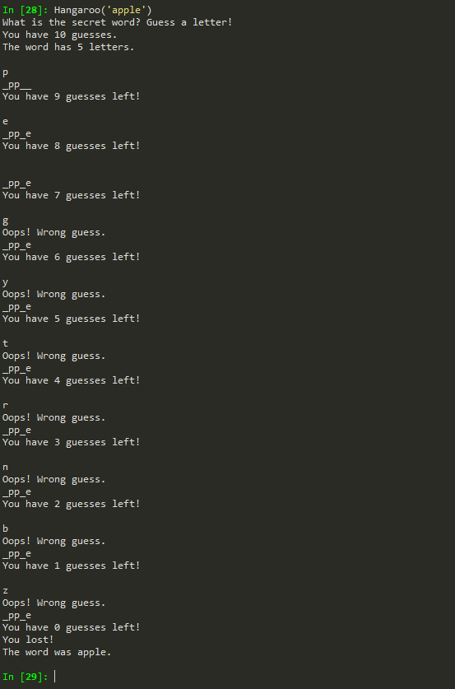The user ran out of guesses

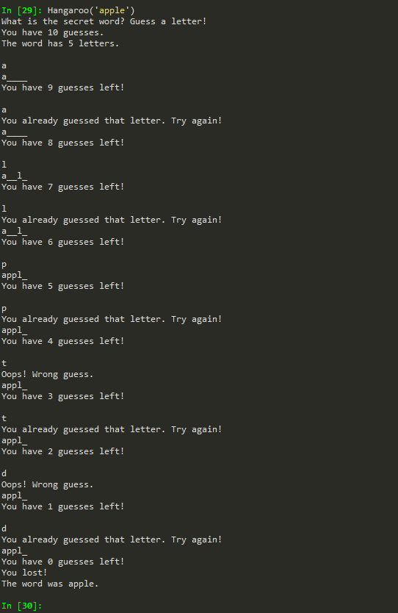The user guessed the same letter